POSTMAN API EVIDENCE SUBMISSION
Student Name: Nida Fatima | Roll No / ID: SU92-BSCSM-F24-192
Subject / Assignment: Web Development - Express.js Modular MVC REST API | Submission Date: October 27, 2026
Screenshot 1: Successful /register and /login Responses
Demonstrates successful user registration (201 Created) and subsequent authentication login (200 OK) returning JWT token.
Part A: POST /api/auth/register
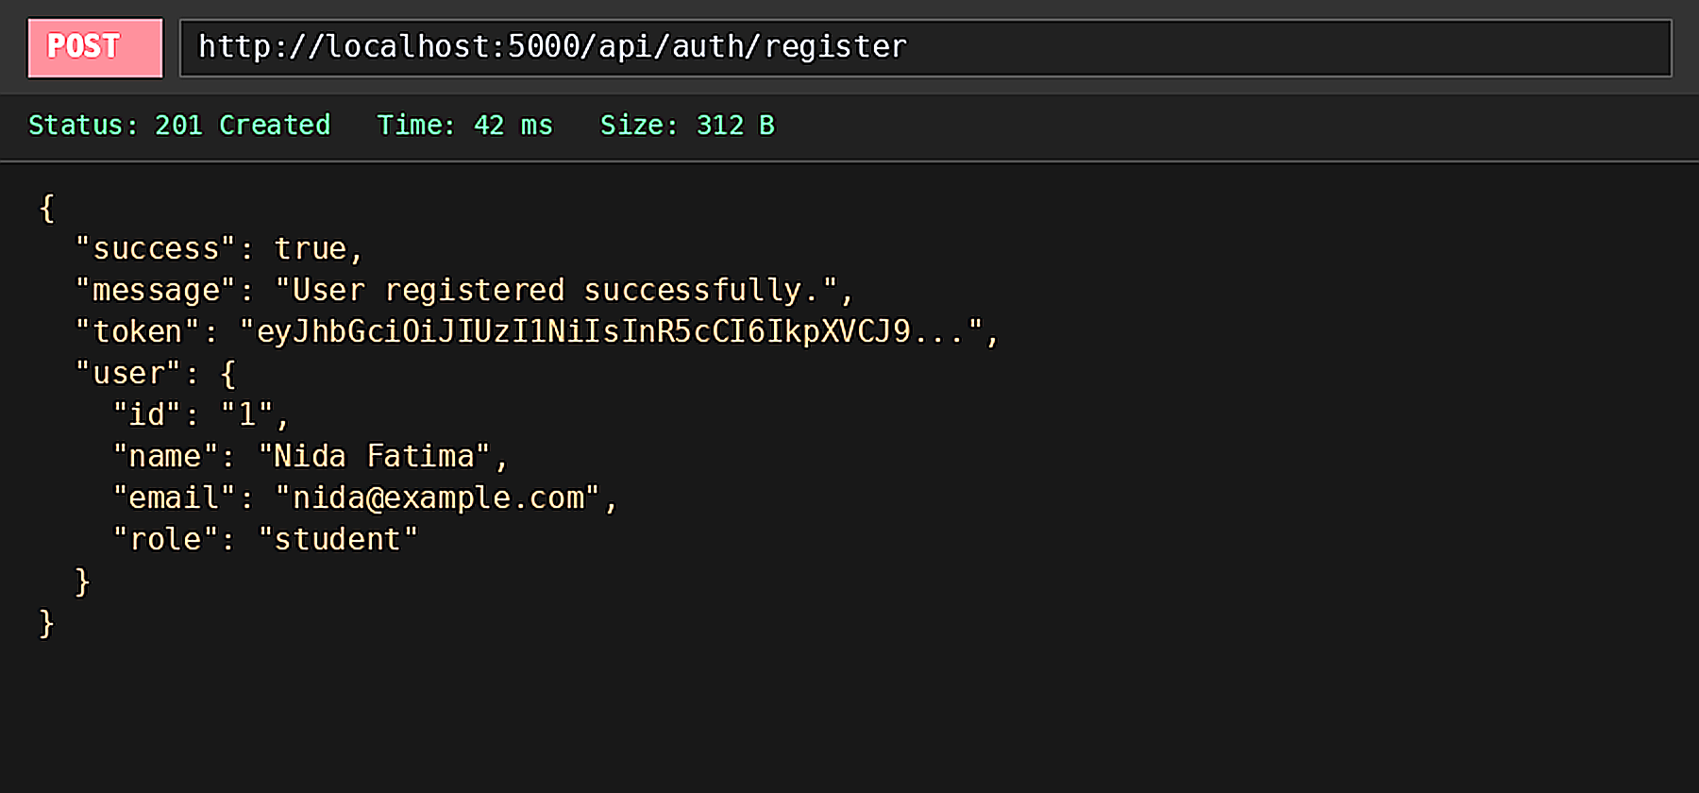
Part B: POST /api/auth/login
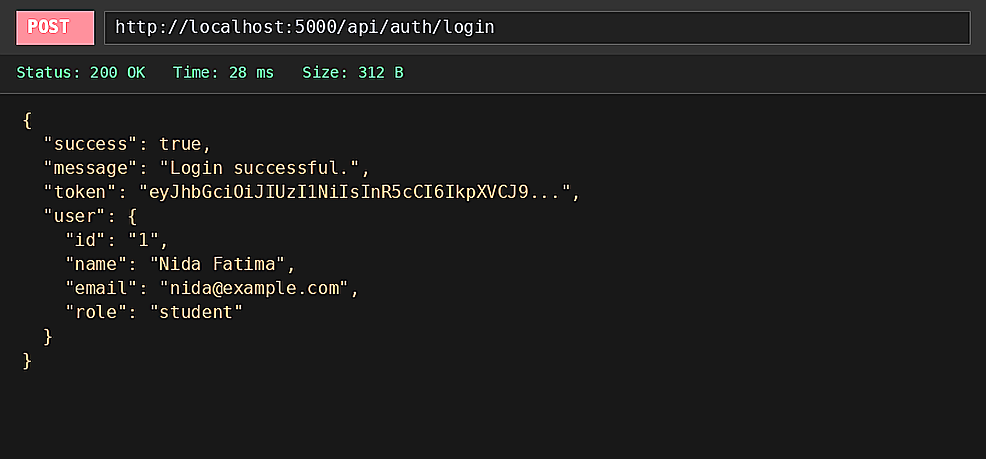
Screenshot 2: POST /api/categories with 201 Created
Demonstrates successful category creation with request payload and HTTP 201 Created response.
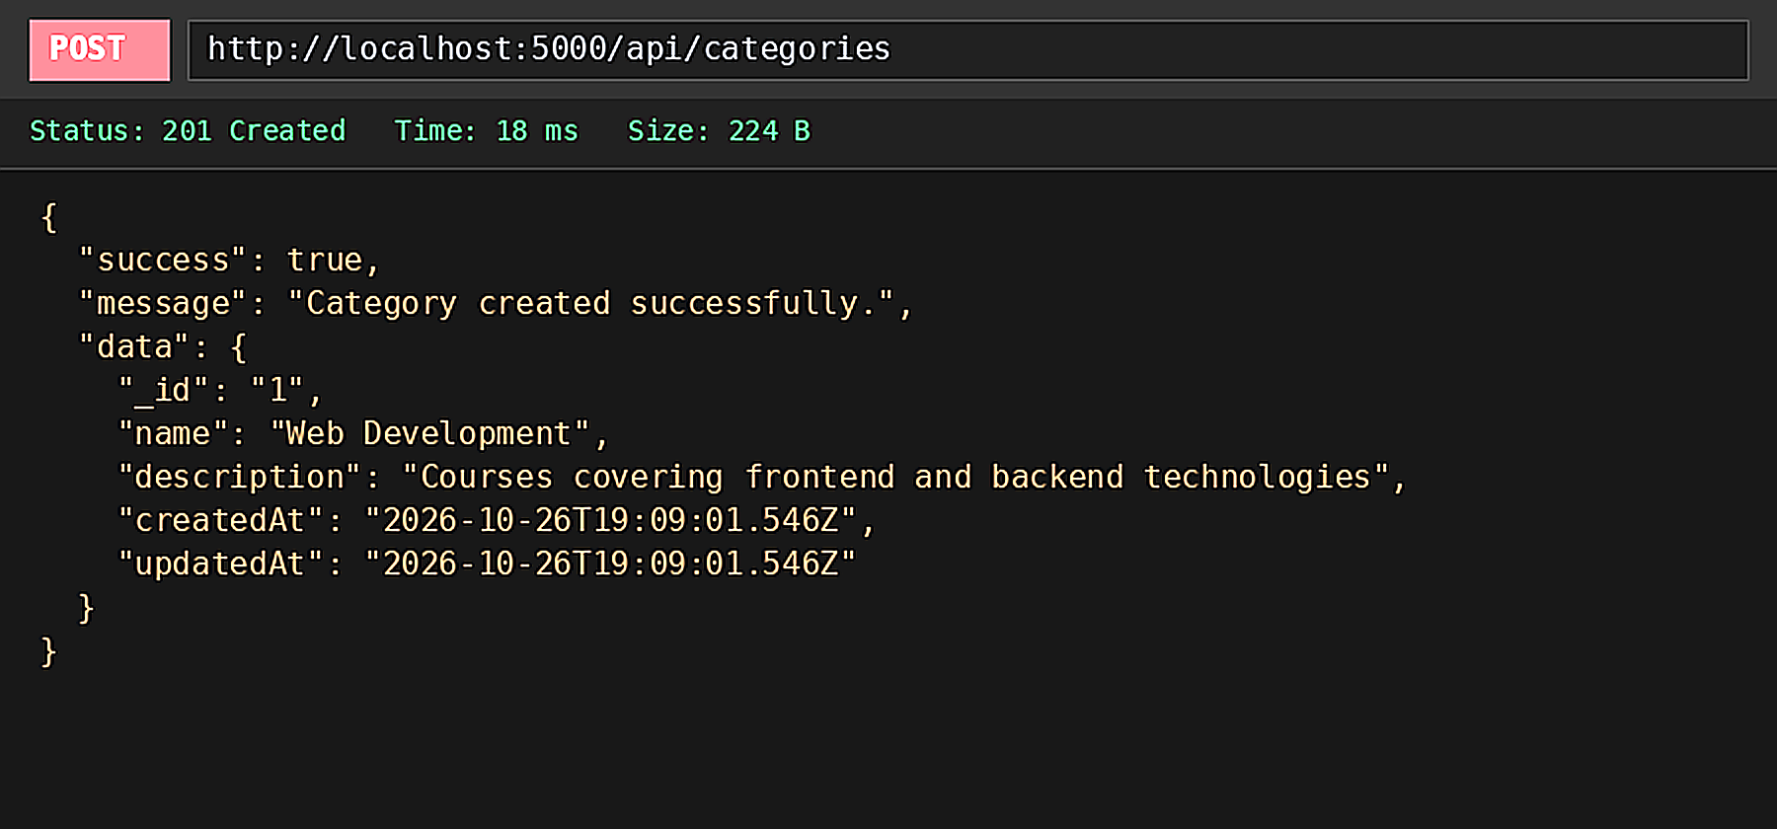
Screenshot 3: GET /api/categories with 200 OK
Demonstrates fetching all categories with HTTP 200 OK status and JSON array response.
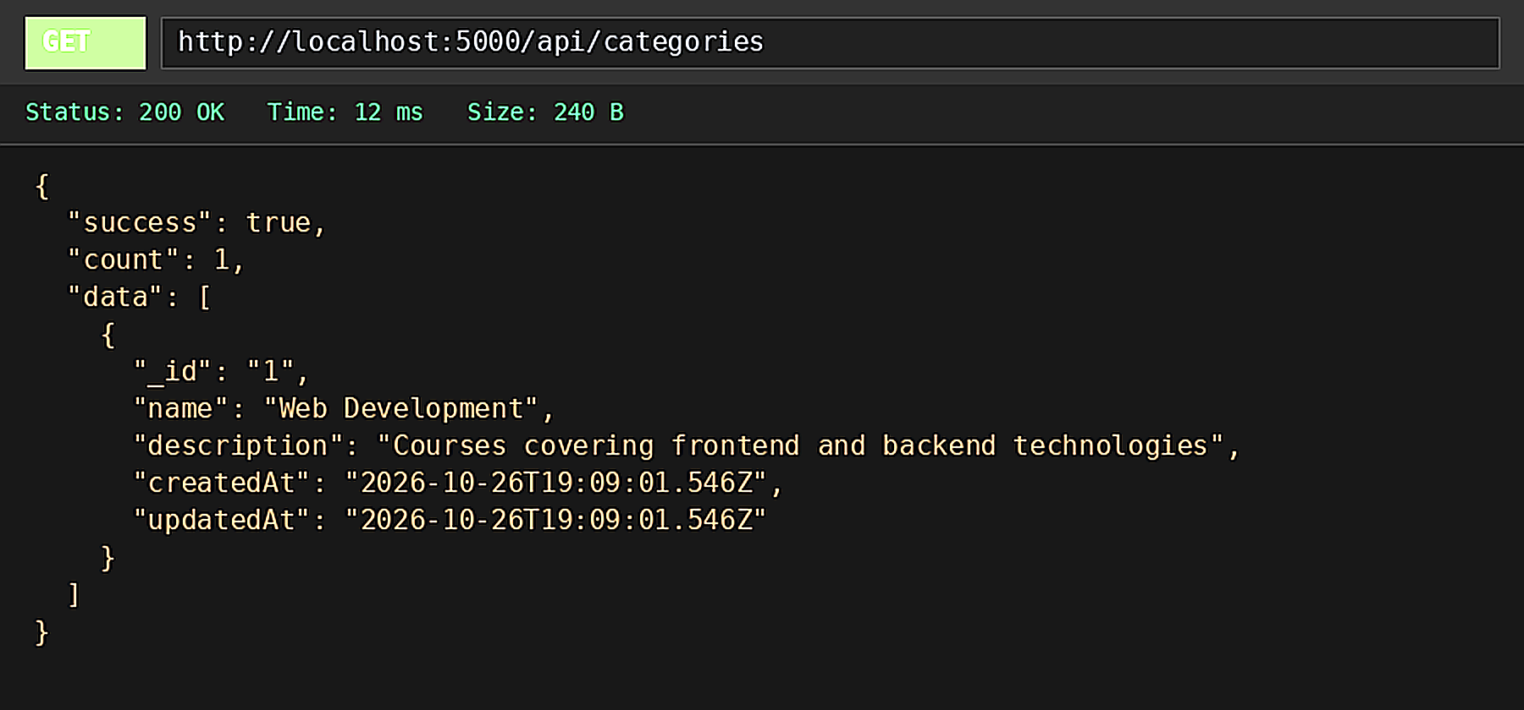
Screenshot 4: 400 Bad Request (Missing Required Field)
Demonstrates server validation error when a mandatory field (name) is missing from the request body.
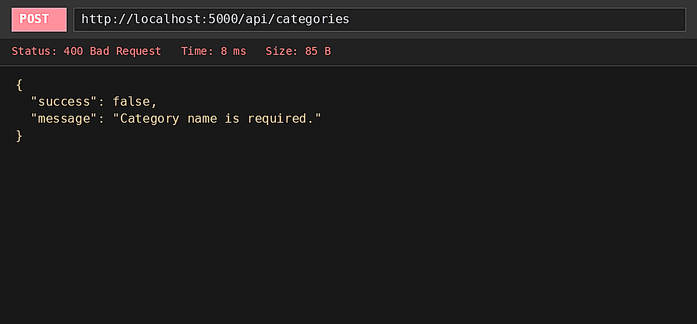
Screenshot 5: 404 Route Not Found (Invalid ID or Unknown URL)
Demonstrates handling of invalid resource ID or nonexistent URL endpoint returning HTTP 404 Not Found.
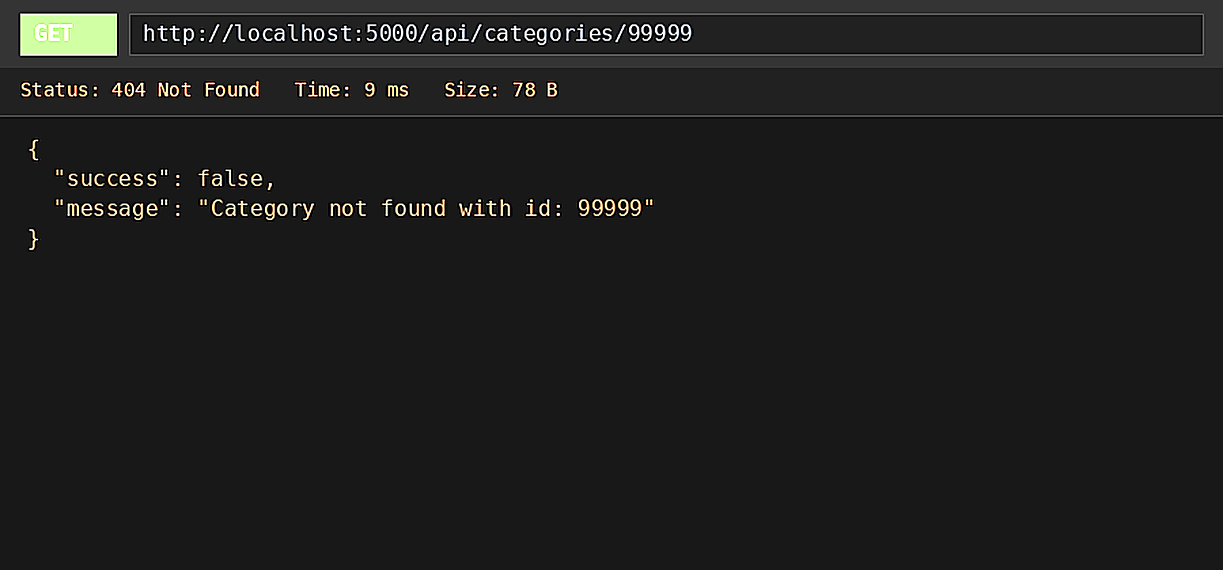
Screenshot 6: Development Environment & Modular Architecture Evidence
Demonstrates the project directory layout (Modular MVC structure with auth, category, and course modules), package.json dependencies, and active Postman collection execution inside VS Code.
